ENTREPRENEURSHIP & CONSULTANCY
Name of the Student
Name of the University
Author Note
Introduction
Entrepreneurship is a process of designing and developing new business on a small scale. It is described as the willingness and capacity of an entrepreneur to create and manage a business by accepting the risks involved in making a profit. A considerable amount of risks involved during the business start-ups. Various risks associated with the business start-ups are funding risks, risks of economic crisis, lack demand from the market and many more. Entrepreneurs are a person or an individual that set up a business start-up by taking the financial risks for gaining profits from the investments. They are a special person who makes innovation to bring unique and extraordinary events. The first part of this paper has discussed the various theories of entrepreneurs and the type of entrepreneurs. The next section has discussed the economic and non-economic benefits of entrepreneurship. The third part is on the importance of government intervene in different kinds of entrepreneurs. The last part is on the limitations of government intervene in the different type of entrepreneurs.
Discussions
Theories of Entrepreneurship
- Economic approaches- Innovation is a tool that can provide opportunities to entrepreneurs for doing business and service. It helps in the economic growth of the country.
- Sociological approaches- It deals with the responsibilities towards the social and cultural factors of the society.
- Personality approaches- Every entrepreneur have different personalities in terms of creativity, imaginative and innovative skills.
- Social-Psychological approaches- These type of entrepreneurs seeks to find out the existing social structure for the economic development of society. The psychological effect of entrepreneurs will affect the attitude of the people of the society.
- Cognitive approaches- This explains the limitations of the traits of entrepreneurs. This includes the various traits of entrepreneurs who have received very little attention towards the business.
Types of Entrepreneurs
According to Landau, there are three types of entrepreneurs. They are:
- Nascent vs. serial entrepreneurs- Nascent entrepreneurs are the people engaged in making innovations in creating new business ventures. Example of a nascent entrepreneur is a student who just start-up a business, which is in the process of development (Morri et al. 2018). Whereas, the serial entrepreneurs are involved in the continuous development of new ideas and solutions for starting a new business. A serial entrepreneur is opposite of a normal entrepreneur who normally come up with a single idea to start their business.
- Necessity vs. opportunity entrepreneurs- Necessity entrepreneurs do not find any better choice of work, so they are engaged in various entrepreneurial activities. Whereas, an opportunity entrepreneur is an individual who is not employed and start seeking opportunities to seek business. This is generally associated with the growth-oriented type of businesses. Yahoo is an excellent example of opportunity entrepreneurs.
- Natural-born vs. accidental entrepreneur: a natural-born entrepreneur is the people who are born with natural qualities that will help them to meet the required expectations of the business. Whereas accidental entrepreneurs are not born with certain qualities for meeting the requirements, they generally find themselves to work on their own for making their business successful (Westhead and Wright 2016).
Benefits of an Entrepreneurial firm
Economic benefits | Non-economic benefits
- Reduce unemployment in the country.  - The income tax generated from the business income can support the government in building economic, social and political aspects of the government.  - It allows the firms to make efficient use of resources to produce the optimum quality of goods and services to attain a competitive position in the world (Jones, Ram and Villares 2019).  - It reduces the flow of imports and maintains balance in any payment deficits.  - Entrepreneurship allows the firms to make innovations in technologies, products and services. This enhances the development of the global market.  - It allows providing a better working environment with a lower rate of absenteeism.  - It promotes the local communities in delivering fishing, coal, steel and mining services, and plays a role model for future generations (Zahra and Wright 2016). | - The most important benefit of entrepreneurship is that it reduces inequalities and enhances wealth creation across the country.  - It provides opportunities to minorities, women, and other disabled individuals to grow themselves in the carrier.  - It provides empowerment in generating personal satisfaction, fulfil the family requirements and taking household responsibilities (Love et al. 2017).  - Entrepreneurship allows the policymakers to make various policies to support the enterprise in making innovations and creation of new ideas (McCamley and Gilmore 2016).

Economic Development
Economic development includes the transformation of stagnant to the growth of the economies from low income to high income by overcoming the problems related to poverty. It depends on deriving value to the society by providing equality, increasing the standard of living, involves political and economic participation, includes personal satisfaction and provides universal education. Economic development was traditionally measured as Gross Development Product and Gross National Product and Per-capita income of a product.
The above economic development can only be achieved by providing welfare to the entire society and creating a situation of human well-being. The government should focus on providing basic requirements of nourishment and health to the people. It should give equal opportunities to every individual to contribute to the economy. Self-sustainable growth is very important for enhancing the economy. This can be possible by focusing more on urban, modern, service and manufacturing sector of the economy. Investments are essential for maintaining the substantial growth in the economy (Naushad, Faridi and Malik 2018). This can be achieved by making more investments from both domestic and international constraints through resource allocation and more access to capital and technology.
Investments can be derived from the following factors:
- If there is effective competition.
- If the producers are more focused on production.
- Technology is freely available to entrepreneurs.
- Distortion by the governments.
- Openness to foreign ideas
- Raising the demands for an activity.
- Interaction of multiple
Hence, entrepreneurs are the individuals that search for an opportunity to invest their funds in various goods and services that can be easily sold at a greater cost. They seek for various ideas by searching the past events and bringing on an extra-ordinary event through innovations.
Factors to stimulate the creation of opportunities for the entrepreneurs
- Creating new ideas: This can be done by searching the past events and brainstorming.
- Creating new combinations of innovations in industries and economic development- Developing new technology process, products and creating a new type of organisation.
- Alertness in opportunity identification- The business opportunities can be identified through knowledge and experience. It helps in dealing with future uncertainties. Collection of various data for identifying future opportunities.
- Having skill in assessing the risks and uncertainties and specialists in making judgements in effective use of resources (Krueger 2017).
- Have the skill to connect their knowledge with their organisational forms. This can be done by linking the ideas and information to their suppliers and customers. They should also have the power to exploit their opportunity in the external environment. This includes a boost in carrying capacity of the firm, legitimation, competition, investigation on new growth avenues, ability to accommodate the organisational changes, unique way of acquiring and organising the inputs to produce the required outputs, cost and product differentiation.
Importance of Government Intervenes to differentiate the different types of Entrepreneurs
To access the above opportunities, the entrepreneurs must aim at achieving a competitive advantage by combining the existing resources in new developments. They have to make a strategic management choice. For this, they will have to access social capital like finance, customers and suppliers. This will help in building a wider range of the network.
For Nascent Entrepreneurs- TEA indicators, which is also known as Total early-stage entrepreneurial activity indicators are used to create motivations to these type of entrepreneurs, who are just in the process of starting a business. It provides the information related to the impact of the business growth in terms of innovations, expected job creations and inclusiveness of gender and age in the business (Stam and Spigel 2016). Entrepreneurship policies by the government will help in bringing new information for wealth creation in these type of entrepreneurs. It provides support and motivations to small firms by providing various information, advice, finances and training to the new or existing small firms. The government will simplify the barriers of new business creation.
For serial entrepreneurs, EEA indicators or Entrepreneurial employee activity indicators are used to calculate the population of the age group between 18-64 involved in continuous development and setting of new business units. They continuously enter into a new type of business; hence the government should help these type of entrepreneurs in providing basic support to enhance their business. A serial entrepreneur may require more resources to access their business internationally and build a more competitive advantage for business innovations (Colombo, Cumming and Vismara 2016). The government can support this type of entrepreneurs by granting and protecting their patents for innovations and design.
Therefore, all the entrepreneurship is not equal, and their needs require various policies for supporting the business. The policy should be democratic and be based on merits. The policies should focus on resource allocation.
It can be noticed that emerging markets have a major impact on the marketing of goods and services.
Characteristics of Emerging markets
- Market Heterogeneity- It is more about fulfilling the demand and creates less demand.
- Social-political Governance: Influenced by religion, business groups, governments and the local community.
- Unbranded Competition- Based on unbranded products and services like household needs, personal computers, liquors and many more.
- Shortage of resources- There is a shortage of various inputs like raw materials, labour and inadequate financial support.
- Inadequate infrastructure- There is no proper banking functions, insufficient information and technologies (Bekaert and Harvey 2017).
Looking into the wants of different types of entrepreneurs, the emerging complexities in the global market has made difficulties for the entrepreneurs to classify their economies. But, according to Khanna and palepu, some markets are faced by institutional voids. Many of the product markets face a lack of third-party information; the capital markets are having a deficiency of banks in the rural areas, the labour markets are having lack of head hunter services in the companies. Government interventions help in minimising the institutional voids of domestic firms. Creation of market and development of the market is necessary than the execution of market orientation.
Governments will favour in the marketing development of these emerging markets through government interventions. Growth of the emerging market can be done by increasing the GDP of a country. This can be done by increasing the revenue, minimise the labour costs and increasing productivity. These markets can be nurtured building networks across the globe. The government can provide a platform of clusters for doing experiments to the new emerging industries. This will help the emerging markets to change their business structure and build a strong network among industries. Some of the examples of emerging industries are creative industries, experience industries, mobile service industries, mobility industries, eco industries and maritime industries. Hence, the most important factor in business growth is value creation. The entrepreneur must have the capacity to create value for the cost paid on the goods and services. Value creation can be developed by understanding the porter’s value chain analysis. It can be reconfigured from traditional to emerging industries (Romaniuk, Dawes and Nenycz 2018). In the case of new emerging industries, the entire activity and restructured sectors use some part of traditional industries that includes business services, ICT and engineering services in common.
But, the networks are constantly changing. The entrepreneurs must take responsibility to manage the various stages of network change. They should coordinate by linking with the members, should support the company by providing the necessary resources, integrating the systems and provide recognition among the industries.
Government Intervenes in differentiating the different types of entrepreneurs is very important to protect the private property and maintain the business based on law and principles of the order. They provide basic requirements of providing goods from taxation system. Government intervention involves environmental regulation and protection acts for the business and provides regulations on working rights.
In case of the necessity non-accidental entrepreneurs, the government will help them in working in their rights to do their own business. They allow a fair opportunity for increasing wealth and providing security for the different type of entrepreneurs. It will automatically decrease unemployment and reduce poverty (Weber and Ang 2016). It reduces inequalities. Therefore, the government intervene is important for such types of entrepreneurs.
Limitations of Government Interventions:
- Government Interventions will help to boost the market performance, but, they do not help to provide a well-functioning market. When there is any kind of disputes arises in the business markets, there are no such mechanisms to resolve their issues. Government has made only certain limited mechanisms like arbitration mechanisms to solve the issues between the investors and the brokers (Lodge and Wegrich 2016). These types of issues have led to hinders in contracting.
- There are various mistakes in entrepreneurial policies. There is a lack of clarity in entrepreneurship objectives in the policies.
- Public support for entrepreneurship is very low, and there is a lack of understanding of how to use the funds.
Various Issues in Government Policies
- It only promotes the success of local entrepreneurs seeking an opportunity.
- There are no such policies to reduce the child workforce to start their business with their perceptions and no such availability of tertiary education (Floetotto, Kirker and Stroebel 2016).
- The policies do not allow entrepreneurs to move freely in the labour market.
These issues in policies agreed by the government will not allow the entrepreneurs to gain incentives. They can gain their incentive by cutting costs, but in the case of government intervene, it is not possible. This can cause inefficient growth and production in the business. It also creates an impact on personal freedom. Entrepreneurs often face very little choice in making decisions on what to produce.
Recommendations
The government should provide a fair polices to prevent stress among these entrepreneurs. They can also offer some innovative solutions to the entrepreneurs for making certain incentive benefits (Lu 2017). They can lower the tax for small businesses.
Conclusion
Therefore, it can be deferred that, government interventions are very much important in creating support the entrepreneurs. But, there is a certain restriction by the governments on promoting the products. The government must focus on providing certain alternative solutions for doing a fair practice for the entrepreneurs.

References
Bekaert, G. and Harvey, C.R., 2017. Emerging equity markets in a globalizing world. Available at SSRN 2344817.
Colombo, M.G., Cumming, D.J. and Vismara, S., 2016. Governmental venture capital for innovative young firms. The Journal of Technology Transfer, 41(1), pp.10-24.
Floetotto, M., Kirker, M. and Stroebel, J., 2016. Government intervention in the housing market: Who wins, who loses?. Journal of Monetary Economics, 80, pp.106-123.
Jones, T., Ram, M. and Villares-Varela, M., 2019. Diversity, economic development and new migrant entrepreneurs. Urban Studies, 56(5), pp.960-976.
Krueger, N.F., 2017. Entrepreneurial intentions are dead: Long live entrepreneurial intentions. In Revisiting the entrepreneurial mind (pp. 13-34). Springer, Cham.
Lodge, M. and Wegrich, K., 2016. The rationality paradox of nudge: Rational tools of government in a world of bounded rationality. Law & policy, 38(3), pp.250-267.
Love, C., Okesina Oluwaseun, O., Ogueyungbo Opeyemi, O., Oluwafemi Temitope, V. and Musa Philip, O., 2017. GREEN ENTREPRENEURSHIP AND ECONOMIC SUSTAINABILITY: A CONCEPTUAL PERSPECTIVE. Theme:“Entrepreneurship and the Knowledge Economy”, p.153.
Lu, X., 2017, July. Government intervention in developing a circular economy---A case study of waste management in Sweden. In 2017 3rd International Conference on Economics, Social Science, Arts, Education and Management Engineering (ESSAEME 2017). Atlantis Press.
McCamley, C. and Gilmore, A., 2016. Entrepreneurial co-creation in emerging heritage tourism regions; the role of entrepreneurial networks.
Morris, M.H., Neumeyer, X., Jang, Y. and Kuratko, D.F., 2018. Distinguishing Types of Entrepreneurial Ventures: An Identity‐Based Perspective. Journal of Small Business Management, 56(3), pp.453-474.
Naushad, M., Faridi, M.R. and Malik, S.A., 2018. Economic development of community by entrepreneurship: an investigation of the entrepreneurial intent and the institutional support to the local community in Al-Kharj region.
Romaniuk, J., Dawes, J. and Nenycz-Thiel, M., 2018. Modeling brand market share change in emerging markets. International Marketing Review, 35(5), pp.785-805.
Stam, F.C. and Spigel, B., 2016. Entrepreneurial ecosystems. USE Discussion paper series, 16(13).
Weber, O. and Ang, W.R., 2016. The performance, volatility, persistence and downside risk characteristics of sustainable investments in emerging market. ACRN Oxford Journal of Finance and Risk Perspectives, 5(2), pp.1-12.
Westhead, P. and Wright, M., 2016. The habitual entrepreneur. Routledge.
Zahra, S.A. and Wright, M., 2016. Understanding the social role of entrepreneurship. Journal of Management Studies, 53(4), pp.610-629.

Appendix
Entrepreneurship
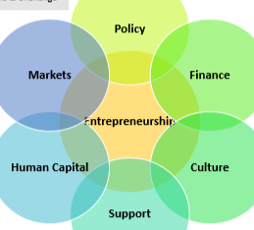
Types of Entrepreneurs
- 
- 
- 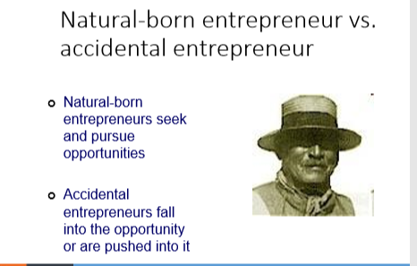
Economic Development
Value Chain Analysis
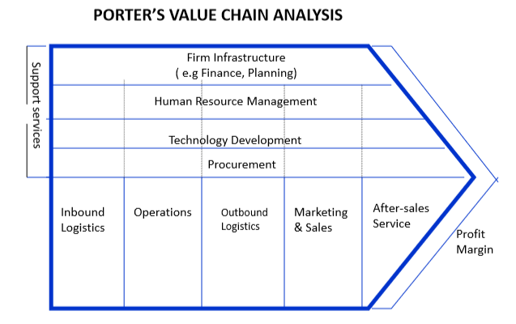
Primary activities:
- Inbound logistics- Control of production inputs from the suppliers.
- Operations- Transforms the inputs to finished products.
- Outbound logistics- Finished products are moved from the factory to retailers and final consumers.
- Marketing & Sales- Use of advertisements and marketing mix to influence the buyers to buy the products.
- Service- Support the customers for any complaints, installations and other after-sale services.
Support activities:
- Procurement- Purchasing of raw materials and other inputs.
- Technology development- Research and development to support the activities.
- Human Resource Management- Includes all labor relation activities like recruitments, development and compensation.
- Firm Infrastructure- Includes various functions like management information systems, legal & regulatory affairs, accounting & finance and safety & security functions.
Importance of Government Intervenes

Limitations of Government Intervenes
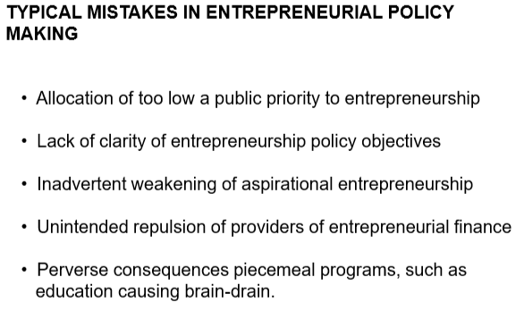
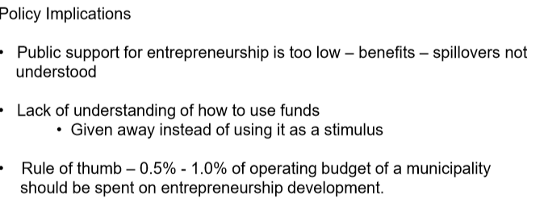
Recommendations
